|  |
| --- |
| **CHAPTER 3:** ***Exponential and Logistic Functions* (Pages 245 – 267)** |
| **Objectives:** |
| Define exponential functions. |
| Distinguish between growth and decay. |
| Graph an exponential function, showing its initial value and its asymptote. |
| How do you find the initial value of an exponential function? |
| **Essential Questions:** |
| What is the model for exponential growth? What is the model for exponential decay? Can you give an actual example of exponential growth? Can you give an actual example of exponential decay? |
| **Technology:** TI-84 plus graphing calculator |

***TUESDAY, 10.29.24***

**Discuss the previously assigned work:**

* Notes on pages 245 – 249.
* Page 255, ***Quick Review***, #1 – 10.
* Page 255, ***Exercises***, #1 – 6.

**Notes:** An exponential function is in the form of f**(*x*) = *abx,*** where *b* > 0, *b* ≠ 1, and *a*, *b*, and *x* are a real numbers.

If **b > 1**, the exponential function will model **growth**.

If **0 < b < 1**, the exponential function will model **decay**.

**Class Work/Homework:**

* **Graph the following.**

1. y = 2 ⋅ 3 x
2. y = 2 ⋅ (1/3)x
3. y = 2 ⋅ x3

* Page 255, ***Exercises*,** #7 – 12.

***THURSDAY, 10.31.24***

**Discuss the previously assigned work:**

* **Graph the following.**

1. y = 2 ⋅ 3 x
2. y = 2 ⋅ (1/3)x
3. y = 2 ⋅ x3

* Page 255, ***Exercises*,** #7 – 12.

**Class Work/Homework:**

* Page 256, #13, 14
* Page 257, #55 - 58

***FRIDAY,11.1.24* A-DAY, NO CLASS**

***TUESDAY, 11.5.24* STUDENT HOLIDAY**

***THURSDAY, 11.7.24, AND FRIDAY, 11.8.24***

**Entry Work:**

A Swiss mathematician **Leonhard Euler** originated the **Natural Number *e*. The value of *e* is _____________________, accurate to 5 decimal numbers.**

Leonhard Euler popularized the use of the number ***π, whose value is ________________________, accurate to 5 decimal numbers.***

Both ***e*** and ***π*** are Complex, Real, and Irrational Numbers. An irrational number is a number that cannot be written as a fraction. ***Irrational*** means **Nonfractional**.

Discuss the hierarchy of the **Complex Number System** below:

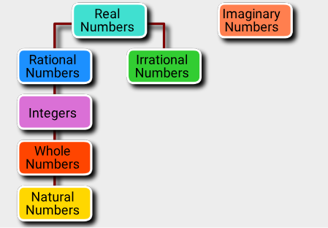

**Discuss the previously assigned work:**

* Page 256, #13, 14
* Page 257, #55 - 58

**Discuss logistic functions.**

**Class Work/Homework:**

* Page 256, #49, and Page 257, #61, 66